GE Gas Turbine Frame 6PG6581(B) - 2 UNITS

**GT FRAME 6 COVERED UNITS READY FOR SELL**

GT Generator 1A

* GE Frame Model PG6581(B)
* Frame 6
* Heavy Duty 38.5 MW
* Gas Turbine Generator 1A
* GT Generator Transformer
* Unit Auxiliary Transformer 1
* Turbine Control Cab
* On base/Off base equipment

GT Generator 1B

* + GE Frame Model PG6581(B)
  + Frame 6
  + Heavy Duty 38.5 MW
* Gas Turbine Generator 1B
* GT Generator Transformer
* Unit Auxiliary Transformer 1
* Turbine Control Cab
* On base/Off base equipment

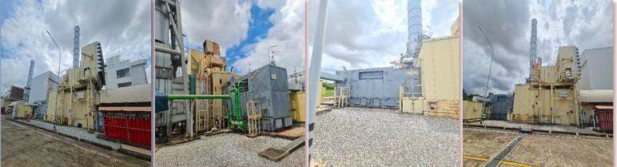



|  |  |  |  |  |  |
| --- | --- | --- | --- | --- | --- |
| **Item** | **Description** | **QTY.** | **Manufacturer** | **Type/Model** | **Output** |
| Gas Turbine Generator 1A | Gas Turbine 1A |  | General Electric | PG 6581 (B) | 42,100 kW |
|  | Gas Turbine Generator 1A | 1 | ALSTOM | T214-234 | - |
|  | Control Cabinet | 1 |  |  | - |
|  | GT Control System | 1 | General Electric | MK V | - |
|  | Unit Auxiliary Transformer 1 | 1 | Fuji Electric | 400 kVA - 11 kV/400V | - |
|  | Inlet Filter House | 1 |  |  |  |
|  | Gas Fuel Control Skid | 1 |  |  |  |
|  | Compressor washing Skid | 1 |  |  |  |
|  | Fire Protection and CO2 Skid | 1 |  |  |  |
|  | Exhaust Plenum and Damper | 1 |  |  |  |
| Gas Turbine Generator 1B | Gas Turbine 1B | 1 | General Electric | PG 6581 (B) | 42,100 kW |
|  | Gas Turbine Generator 1B | 1 | ALSTOM | CE-240 ATP3 | - |
|  | Control Cabinet | 1 |  |  | - |
|  | GT Control System | 1 | General Electric | MK V | - |
|  | Unit Auxiliary Transformer 1 | 1 | Fuji Electric | 400 kVA - 11 kV/400V | - |
|  | Inlet Filter House | 1 |  |  |  |
|  | Gas Fuel Control Skid | 1 |  | - | - |
|  | Compressor washing Skid | 1 | - | - | - |
|  | Fire Protection and CO2 Skid | 1 |  |  |  |
|  | Exhaust Plenum and Damper | 1 |  |  |  |

|  |  |  |
| --- | --- | --- |
|  | **GTG 1A** | **GTG 1B** |
| **Gas Turbine Type/ Model** | GE Energy Products / PG 6561 B | GE Energy Products / PG 6561 B |
| **Turbine Sr. No** | (To be provided) | (To be provided) |
| **Maker** | GE Energy Products GermanyGmbH | GE Energy Products GermanyGmbH |
| **Load Type** | Generator | Generator |
| **Fuel Type** | Natural Gas (NG) | Natural Gas (NG) |
| **Rated Output (MW)** | 42 MW | 42 MW |
| **Rated Speed (rpm)** | 5100 | 5100 |
| **Control system** | EMERSON/OVATION,  GE/Mark V | EMERSON/OVATION,  GE/Mark V |
| **Acc. Gear/ Type** | BHS/A619 | BHS/A619 |
| **Load Gear/ Type** | Flender/TRL65CV | Flender/TRL65CV |
| **Generator/ Type** | ALSTOM/T190-240 | ALSTOM/T190-240 |
| **Generator speed (rpm)** | 1,500 | 1,500 |

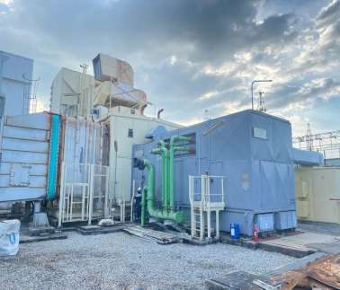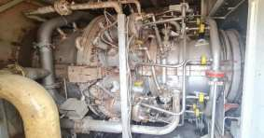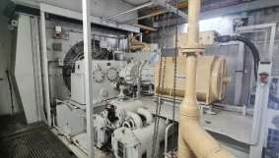

*\*Remark: Operating data recorded on June 27, 2023.*

**TOTAL UNIT EQUIVALENT OPERATING HOURS, STARTS, TRIPSSINCE COMMISSIONING (AS OF JANUARY 28, 2003)**

|  |  |  |  |  |  |
| --- | --- | --- | --- | --- | --- |
| **NAME** | **UNIT** | **COD (Date)** | **No. of Starts** | **No. of Trips** | **EOH (Hrs.)** |
| GAS TURBINE | 1A | Jan 28, 2003 | 298 | 62 | 171,772 |
| GAS TURBINE | 1B | Jan 28, 2003 | 263 | 51 | 163,831 |

**EQUIVALENT OPERATING HOURS AFTER LAST MAINTENANCE**

|  |  |  |  |  |
| --- | --- | --- | --- | --- |
| **NAME** | **UNIT** | **COD (Date)** | **Last Maintenance** | **EOH (Hrs.)** |
| GAS TURBINE | 1A | Jan 28, 2003 | MO (28.4.2021) | 17,510 |
| GAS TURBINE | 1B | Jan 28, 2003 | HGPI (22.02.2023) | 2,324 |

|  |  |  |  |  |
| --- | --- | --- | --- | --- |
| **Item** | **Description** | **Unit** | **GTG-1A** | **GTG-1B** |
| 1 | Test date | - | 21 Feb 2023 | 28 Feb 2023 |
| 2 | Test time | hh.mm | 14.30 | 14.30 |
| 3 | Ambient pressure | mbar | 1,002.334 | 1,004.887 |
| 4 | Ambient temperature | °C | 33.702 | 33.00 |
| 5 | Wet bulb temperature | °C | 25.000 | 24.50 |
| 6 | GT Net Power Output  Corrected | kW | 34,479.168 | 31,995.839 |
| 7 | Net Power Output Corrected | kW | 51,641.663 | 47,069.121 |
| 8 | Net Heat Rate of each Block corrected (LHV) | Btu/kWh | 8,512.652 | 8,969.129 |
|  |  | kJ/kWh | 8,981.324 | 9,462.944 |

PERFORMANCE TEST REPORT

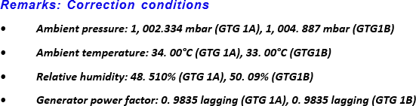

MAINTENANCE CYCLE RECORD

|  |  |  |  |  |  |  |
| --- | --- | --- | --- | --- | --- | --- |
| **Year** | **Gas Turbine 1A (GTG1A)** | **Start** | **Finish** | **Gas Turbine 1B (GTG1B)** | **Start** | **Finish** |
| 2003 | - | - | - | - | - | - |
| 2004 | WI | 04-Jan-04 | 08-Jan-04 | WI | 09-Jan-04 | 12-Jan-04 |
| 2005 | - | - | - | HGPI | 03-Jan-05 | 13-Jan-05 |
| 2006 | HGPI | 31-Dec-05 | 07-Jan-06 | MI | 08-Jul-06 | 11-Jul-06 |
| 2007 | - | - | - | - | - | - |
| 2008 | - | - | - | MGO | 23-Mar-08 | 16-Apr-08 |
| 2009 | MGO | 01-Apr-09 | 25-Apr-09 | - | - | - |
| 2010 | - | - | - | - | - | - |
| 2011 | - | - | - | HGPI | 10-Apr-11 | 19-Apr-11 |
| 2012 | HGPI | 11-Feb-12 | 21-Feb-12 | - | - | - |
| 2013 | - | - | - | - | - | - |
| 2014 | - | - | - | MGO | 03-Mar-14 | 25-Mar-14 |
| 2015 | MGO | 04-Jan-15 | 28-Jan-15 | - | - | - |
| 2016 | - | - | - | - | - | - |
| 2017 | - | - | - | HGPI | 05-Mar-17 | 25-Mar-17 |
| 2018 | HGPI | 07-Jan-18 | 16-Jan-18 | - | - | - |
| 2019 | - | - | - | - | - | - |
| 2020 | - | - | - | MGO | 05-Feb-20 | 29-Feb-20 |
| 2021 | MGO | 04-Apr-21 | 28-Apr-21 | - | - | - |
| 2022 | - | - | - | - | - | - |
| 2023 | - | - | - | HGPI | 13-Feb-23 | 22-Feb-23 |

**NOTE:**

**CI – Combustion Inspection HGPI – Hot Gas Path Inspection MGO – Major Overhaul**

**MI – Minor Inspection**

**WI – Warranty Inspection**

Gas Turbine 1A – Major Overhaul Maintenance Capital Parts History

Date: 28 April 2021

Operating Hours: 154,262 Hrs. (Actual)

|  |  |  |  |  |  |
| --- | --- | --- | --- | --- | --- |
| **ITEM** | **STOCK NO.** | **REPLACEMENT PARTS NAME** | **Q’ty.** | **FIRE HOURS** | **PARTS CONDITION** |
| 1 | - | Stage 1 Buckets | 1 set | 0 | New |
| 2 | - | Stage 2 Buckets | 1 set | 49,300 | Repair |
| 3 | - | Stage 3 Buckets | 1 set | 0 | New |
| 4 | - | Stage 1 Nozzles | 1 set | 24,700 | Repair |
| 5 | - | Stage 2 Nozzles | 1 set | 24,700 | Repair |
| 6 | - | Stage 3 Nozzles | 1 set | 0 | New |
| 7 | - | Stage 1 Shroud Blocks | 1 set | 0 | New |
| 8 | - | Stage 2 Shroud Blocks | 1 set | 0 | New |
| 9 | - | Stage 3 Shroud Blocks | 1 set | 0 | New |
| 10 | - | Fuel Nozzle | 1 set | 83,200 | Repair |
| 11 | - | Combustion Liner | 1 set | 71,500 | Repair |
| 12 | - | Transition Piece | 1 set | 25,000 | Repair |

Gas Turbine 1B – HGPI Maintenance Capital Parts History Date: 22 February 2023

Operating Hours: 161,507 Hrs. (Actual)

|  |  |  |  |  |  |
| --- | --- | --- | --- | --- | --- |
| **ITEM** | **STOCK NO.** | **REPLACEMENT PARTS NAME** | **Q’ty.** | **FIRE HOURS** | **PARTS CONDITION** |
| 1 | - | Stage 1 Buckets | 1 set | 52,450 | Repair |
| 2 | - | Stage 2 Buckets | 1 set | 52,450 | Repair |
| 3 | - | Stage 3 Buckets | 1 set | 26,743 | Repair |
| 4 | - | Stage 1 Nozzles | 1 set | 26,743 | Repair |
| 5 | - | Stage 2 Nozzles | 1 set | 52,450 | Repair |

|  |  |  |  |  |  |
| --- | --- | --- | --- | --- | --- |
| 6 | - | Stage 3 Nozzles | 1 set | 52,450 | Repair |
| 7 | - | Stage 1 Shroud Blocks | 1 set | 52,450 | Repair |
| 8 | - | Stage 2 Shroud Blocks | 1 set | 52,450 | Repair |
| 9 | - | Stage 3 Shroud Blocks | 1 set | 52,450 | Repair |
| 10 | - | Fuel Nozzle | 1 set | 76,000 | Repair |
| 11 | - | Combustion Liner | 1 set | 76,000 | Repair |
| 12 | - | Transition Piece | 1 set | 94,000 | Repair |

